Genesis 41:46-49
⁴⁶ Joseph was thirty years old when he entered the service of Pharaoh king of Egypt. And Joseph went out from Pharaoh’s presence and travelled throughout Egypt. ⁴⁷ During the seven years of abundance the land produced plentifully. ⁴⁸ Joseph collected all the food produced in those seven years of abundance in Egypt and stored it in the cities. In each city he put the food grown in the fields surrounding it. ⁴⁹ Joseph stored up huge quantities of grain, like the sand of the sea; it was so much that he stopped keeping records because it was beyond measure.
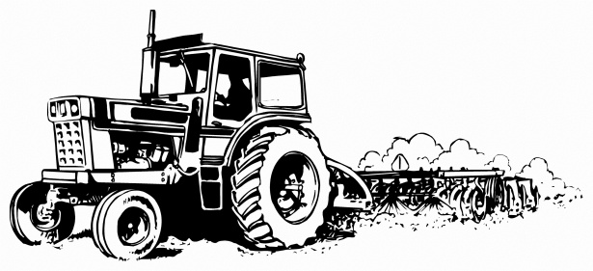

Luke 8:4-15
⁴ While a large crowd was gathering and people were coming to Jesus from town after town, he told this parable: ⁵ “A farmer went out to sow his seed. As he was scattering the seed, some fell along the path; it was trampled on, and the birds ate it up. ⁶ Some fell on rocky ground, and when it came up, the plants withered because they had no moisture. ⁷ Other seed fell among thorns, which grew up with it and choked the plants. ⁸ Still other seed fell on good soil. It came up and yielded a crop, a hundred times more than was sown.”
When he said this, he called out, “Whoever has ears to hear, let them hear.”
⁹ His disciples asked him what this parable meant. ¹⁰ He said, “The knowledge of the secrets of the kingdom of God has been given to you, but to others I speak in parables, so that,
“‘though seeing, they may not see;
though hearing, they may not understand.’
¹¹ “This is the meaning of the parable: The seed is the word of God. ¹² Those along the path are the ones who hear, and then the devil comes and takes away the word from their hearts, so that they may not believe and be saved. ¹³ Those on the rocky ground are the ones who receive the word with joy when they hear it, but they have no root. They believe for a while, but in the time of testing they fall away. ¹⁴ The seed that fell among thorns stands for those who hear, but as they go on their way they are choked by life’s worries, riches and pleasures, and they do not mature. ¹⁵ But the seed on good soil stands for those with a noble and good heart, who hear the word, retain it, and by persevering produce a crop.

