A famer went out to sow his seed….
You can watch this sermon on our YouTube channel using this link Plough Sunday
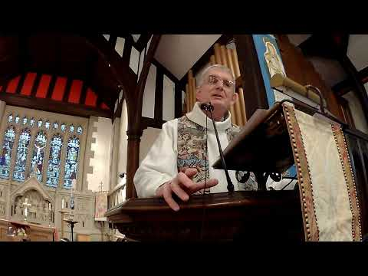

We call this parable the parable of the sower and the seed. But of course if we listen carefully it’s not about the sower, and it’s not about the seed, it’s about the earth. A farmer needs to know his earth.
I was talking to a farmer who told me that when he was a young man he took on a farm. The previous farmer was retiring, but he had one piece of advice for his young successor. “Keep it grass side up and you’ll be alright.”
The young farmer remembered the advice, and he did quite well with his cattle and sheep, but he wanted to try to grow something. So he hired a plough and he ploughed one of his fields. The soil seemed good. He planted potatoes. They potatoes grew. Soon he had the encouraging sight of a healthy field of green. He was rather pleased.
Until autumn came, and with it rain. It rained, and it rained and it rained. The earth became waterlogged. The earth turned to mud. It was impossible to harvest his potatoes.
He was disappointed, but he was made of sterner stuff, and he didn’t give up. He told me he tried again, different crops, for three or four years. But it never went well. In the end he turned it back into pasture, and remembered the old famer’s advice. Keep it grass side up. He’s farmed it that way ever since.
Knowing your earth matters. I remember moving into a brand new vicarage in Warrington. It was just round the corner from Ikea, part of the sprawling Westbrook newtown development. You may remember the advertisements, call Eileen Bilton in Warrington Runcorn, the nation’s most central location. I wonder whatever happened to Eileen Bilton? She’s probably a dinner lady these days.
Anyway, back to the new vicarage. The builder had done what builders always do and scooped up all the topsoil and sold it for a profit. Our garden was solid clay, and it didn’t help that it had been the builders’ yard so it was well compressed.
One of my less brilliant ideas was to hire a rotivator to create a vegetable plot. It was with great enthusiasm that I filled it full of petrol and pulled on the starter cord.
What happened next remains something of a blur. My expectation was that the blades would dig deep into the soil and turn it into a rich deep loam I could plant some runner beans in. The reality was that the rotivator turned out to have a mind of its own and decided this was its opportunity to go off like Nigel Mansell from pole position.
Foolishly I didn’t let go – no, I clung on for dear life and man and machine shot across the garden and nearly through the brand new fence.
You might have thought that my good lady wife, watching from the upstairs window, would be concerned that her beloved was at the meecy of some mechanical monster. Not a bit of it, she was rolling around in laughter, finding the whole event wonderfully entertaining.
I didn’t know my earth. If I had I’d have approached the whole escapade with considerably more caution.
Jesus knew his earth, but more importantly he knew his people. There are those like the path – hard and barren. Nothing good can take root in them.
There are others who are like rocky ground. Things might take root but there’s no depth to them and good things soon fizzle out.
Others have lives so busy and preoccupied, usually with themselves, that they are like thorny ground. Good things might spring up, they might be the latest novelty, and grow for a short while – but pretty quickly they lose interest, it is too hard, it is not exciting enough, and the new hope is smothered.
But there are some who are good earth. God’s word can take root in them, it will be fragile and small, but the earth had depth and goodness and the young plant can grow. Such people have staying power. They can survive drought and storm. They produce a harvest – they bear fruit.
I wonder how Jesus came to tell that story? I suspect it echoes his own experience of people. He must have met many people. He saw those whose hearts and minds were closed. He knew those who greeted something new and interesting, but were too soon distracted by another novelty. He understood those who would follow and seem keen, but quickly gave up. And he met a few who listened, and listened hard, who were resilient and patient. People who heard God’s word and in whom it formed deep roots.
A farmer knows his earth. He understands what the earth can produce, he also understands what the earth needs. We cannot just take from the earth, we need to also give back.
I have watched farmers ploughing. I was interested to see a field that had become compacted and waterlogged ploughed deeply to break the earth up. I have seen ploughs followed by flocks of birds indicating earth that teems with life, and other ploughs ploughing a lonely furrow, where the earth had died. And I have watched the harrow, breaking the surface ready for sowing.
We have been through some hard times. Our lives have been deeply broken. We have been through harrowing times. We find that word has another meaning. We speak of a harrowing experience, which we would prefer to avoid, but then of harrowing the earth, making it ready to bear a new harvest.
Maybe when we reflect on these times, when our lives have been overturned and harrowed, we might remember the earth, that God acts in those who can bear good things, and trusts those who can bear a harvest.

